K.TEJOVANTH (192512063)

Experiment No. 1 Generation and Classification of Continuous-Time and Discrete-Time Signals

MATLAB Coding
% Experiment 1: Generation of Continuous-Time Signals
clc;
clear;
close all;
t = -1:0.001:1;
A = 2;
f0 = 5;
a = 1;
% Generate signals
imp = double(abs(t) < 0.0005);
step = double(t >= 0);
ramp = t .* step;
expSig = exp(-a*t) .* step;
sinSig = A * sin(2*pi*f0*t);

% Plot signals
figure;
subplot(3,2,1);
plot(t, imp);
grid on;
title('192512063 Unit Impulse');
xlabel('t');
ylabel('Amplitude');
subplot(3,2,2);
plot(t, step);
grid on;
title('192512063 Unit Step');
xlabel('t');
ylabel('Amplitude');
subplot(3,2,3);
plot(t, ramp);
grid on;
title('192512063 Ramp');
xlabel('t');
ylabel('Amplitude');
subplot(3,2,4);
plot(t, expSig);
grid on;
title('192512063 Exponential');
xlabel('t');
ylabel('Amplitude');
subplot(3,2,5);
plot(t, sinSig);
grid on;
title('192512063 Sinusoidal');
xlabel('t');
ylabel('Amplitude');
sgtitle('Input and Output Graphs');

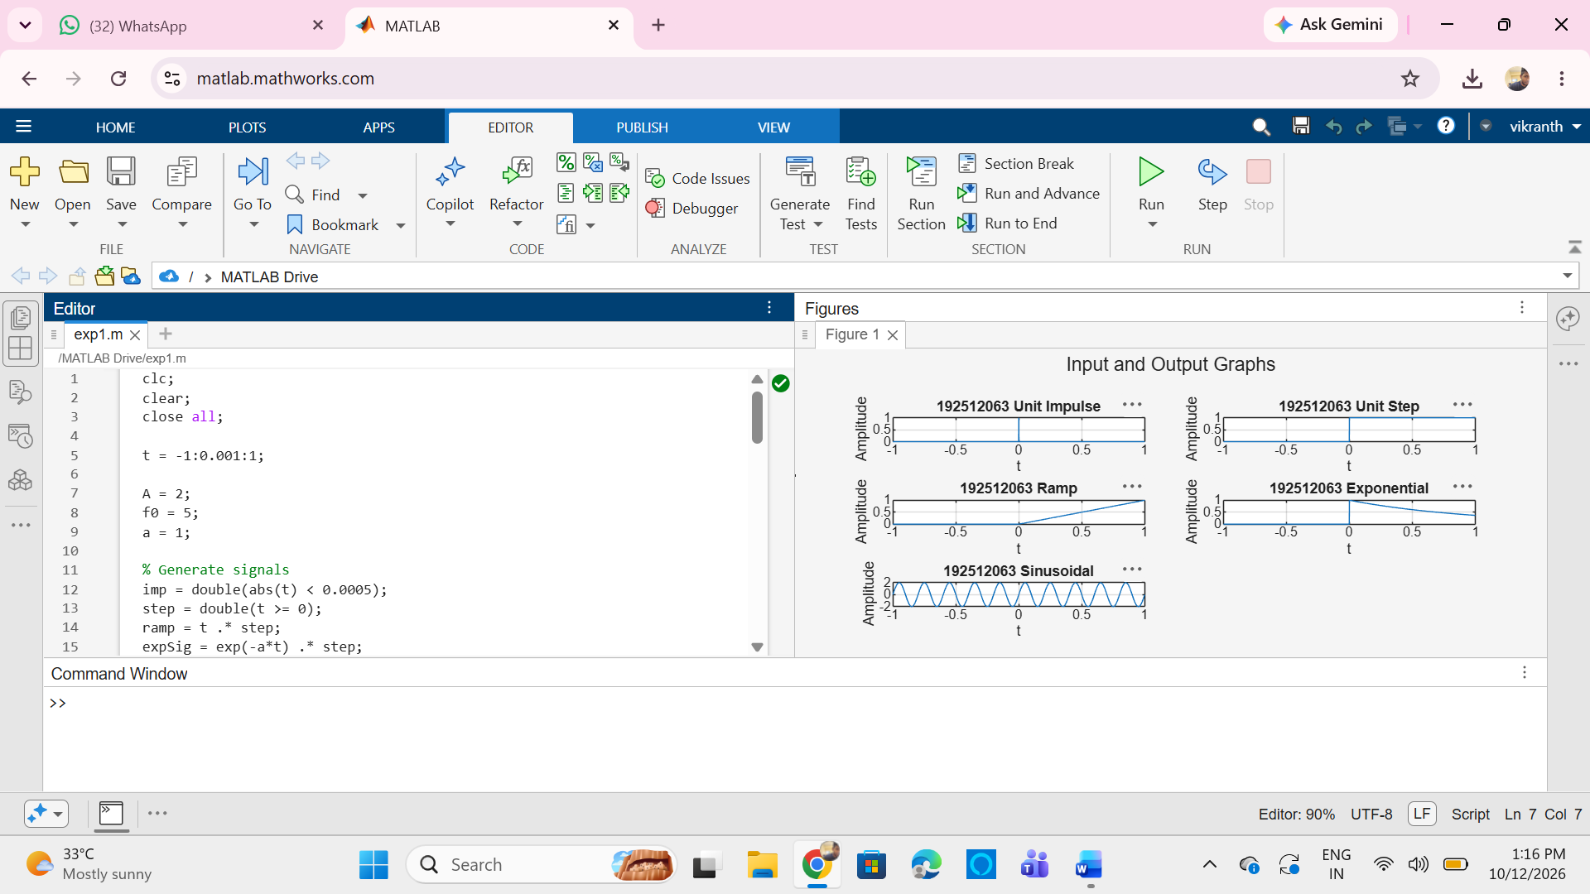

(ii) To generate and visualize basic discrete-time signals and analyze their amplitude and time-index characteristics
MATLAB Coding
% Experiment 2: Generation of Discrete-Time Signals
clc;
clear;
close all;
n = -20:20;
A = 2;
f0 = 0.1;
% Unit Impulse Signal
imp = double(n == 0);
% Unit Step Signal
step = double(n >= 0);
% Ramp Signal
ramp = n .* step;
% Exponential Signal
expSig = (0.8).^n .* step;
% Discrete-Time Sinusoidal Signal
sinSig = A * sin(2*pi*f0*n);
% Plot all signals
figure;
subplot(3,2,1);
stem(n, imp, 'filled');
grid on;
title('192512063 Unit Impulse');
xlabel('n');
ylabel('Amplitude');
subplot(3,2,2);
stem(n, step, 'filled');
grid on;
title('192512063 Unit Step');
xlabel('n');
ylabel('Amplitude');
subplot(3,2,3);
stem(n, ramp, 'filled');
grid on;
title('192512063 Ramp');
xlabel('n');
ylabel('Amplitude');
subplot(3,2,4);
stem(n, expSig, 'filled');
grid on;
title('192512063 Exponential');
xlabel('n');
ylabel('Amplitude');
subplot(3,2,5);
stem(n, sinSig, 'filled');
grid on;
title('192512063 Discrete Sinusoid');
xlabel('n');
ylabel('Amplitude');
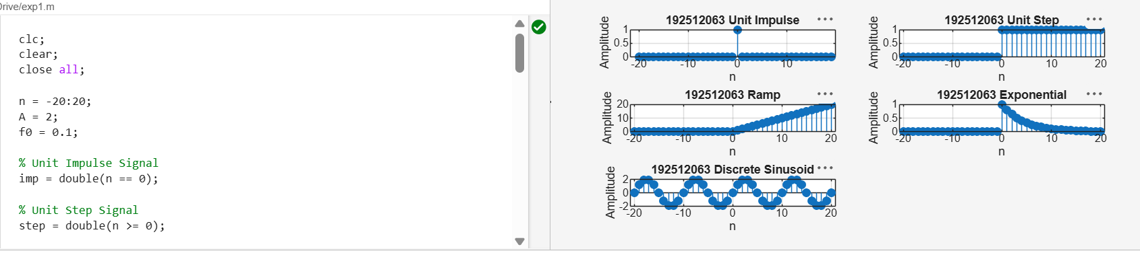
(iii) To generate and classify continuous-time and discrete-time signals as periodic or aperiodic based on their periodicity characteristics
MATLAB Coding
% Experiment 5: Periodic and Aperiodic Signals
Clc;
clear;
close all;
t = 0:0.001:2;
f0 = 5;
% Periodic Signal (Sinusoidal)
xP = sin(2*pi*f0*t);
% Aperiodic Signal (Decaying Exponential)
xA = exp(-t);
% Plot the signals
figure;
subplot(2,1,1);
plot(t, xP);
grid on;
title('192512063 Periodic Signal: Sinusoid');
xlabel('Time (s)');
ylabel('Amplitude');
subplot(2,1,2);
plot(t, xA);
grid on;
title('192512063 Aperiodic Signal: Decaying Exponential');
xlabel('Time (s)');
ylabel('Amplitude');

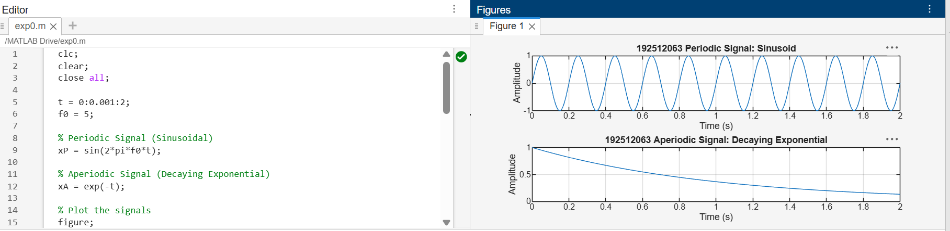
(iv) To decompose a given signal into its even and odd components and verify the reconstruction of the original signal
MATLAB Coding
% Experiment 6: Even and Odd Signal Decomposition.
clc;
clear;
close all;
t = -1:0.001:1;
% Input Signal
x = sin(2*pi*5*t) + 0.5*cos(2*pi*3*t);
% Time-Reversed Signal
xr = fliplr(x);
% Even and Odd Components
xe = (x + xr)/2;
xo = (x - xr)/2;
% Reconstructed Signal
xrec = xe + xo;
% Plot the Signals
figure;
subplot(2,2,1);
plot(t,x);
grid on;
title('192512063 Input x(t)');
xlabel('Time (s)');
ylabel('Amplitude');
subplot(2,2,2);
plot(t,xe);
grid on;
title('192512063 Even Component');
xlabel('Time (s)');
ylabel('Amplitude');
subplot(2,2,3);
plot(t,xo);
grid on;
title('192512063 Odd Component');
xlabel('Time (s)');
ylabel('Amplitude');
subplot(2,2,4);
plot(t,xrec);
grid on;
title('192512063 Reconstructed x(t)');
xlabel('Time (s)');
ylabel('Amplitude');
% Calculate Reconstruction Error
fprintf('Maximum reconstruction error = %g\n', max(abs(x-xrec)));
